The preference of different mobile phone features is a very subjective choice. It could involve pursuing high-end computing performance with the most advanced hardware, the preference of operating systems, requirement for battery capacity, physical appearance, price and etc[1][2]. The complex evaluation metrics makes it difficult to define a ‘good’ mobile phone, thus, makes it difficult to define a successful innovation through the innovation it self. Furthermore, a ‘good and innovative’ mobile phone is not the only key to build a successful mobile company, it takes efforts on the management of development and expanding strategy, capital games, a proper market, outstanding supply chain management ,cost control and a series of conditions to operate a company[3]. A better business model often beats the idea of innovative technology[4].

However, data could tell the attemptation on innovation of product differentiation[5] and the response from peer companies. Theoretically, a successful new feature of a product would experience a diffusion period and expand to new adopters, and further forms a new market[6]. Meanwhile, practically, the new features are often to be replaced by the more advanced next generation features[6]. Such evolution results in the iteration of a new market(evidence can be found in scatter plots of feature vs time). Thus, identifying the iteration of features is critical to define if a new feature has actually created and led a new market. Through assessing the iteration frequency of new features, we can further identify the ambition of companies on innovative features, the higher frequency of iteration on a certain feature indicates the market's aspirant on this feature, and hence, the market’s aspirant indicates the importance of different features.

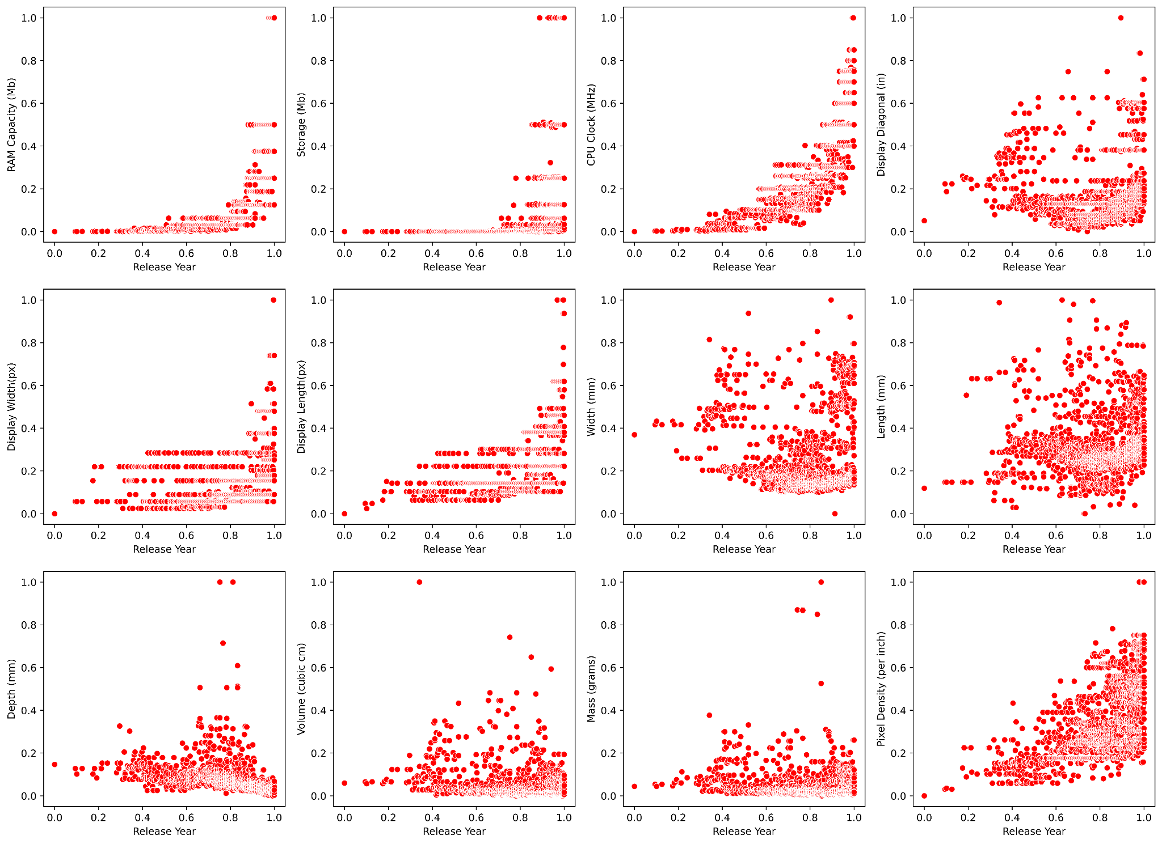

The innovation diffusion period and iteration for RAM/Storage/CPU Clock/Display Width and Length/Pixel is pretty clear on time-series scatter plot. These features are in the microelectronics industry or highly related to microelectronics performance. The iteration of the microelectronics industry following Moore’s Law and have a clear routine in updating hardware performance[7], such routine creates a clear boundary of innovation diffusion period. Yet the display diagonal/width/length/depth/volume/mess does not have a clear iteration behaviour in the time scale of the assignment dataset. It is because preference of appearance or shape size of mobile phones is mostly following the normal distribution[8], and a larger size does not always mean a better choice. Therefore, the more a size feature close to the mean size on the market, it is more likely to be preferred by customers and successful.

No formal reference format added due to uncertain reference style:

[1]<https://www.poundit.com/blogs/updates/102709313-the-10-most-important-specs-when-choosing-a-smartphone#:~:text=Battery%20Life,miliampere%2Dhours%20(mAh)>.

[2]https://www.androidcentral.com/android-central-staffs-most-important-features-phone

[3][Medhi, P.K.](https://www-emerald-com.ezproxy.library.sydney.edu.au/insight/search?q=Pankaj%20Kumar%20Medhi) and [Mondal, S.](https://www-emerald-com.ezproxy.library.sydney.edu.au/insight/search?q=Sandeep%20Mondal) (2015), "The changing dynamics in the worldwide mobile phone market: creating excellence through innovation management and collaborative relationships", [Emerald Emerging Markets Case Studies](https://www-emerald-com.ezproxy.library.sydney.edu.au/insight/browse/case-studies?collections=EEMCS), Vol. 5 No. 1. <https://doi-org.ezproxy.library.sydney.edu.au/10.1108/EEMCS-02-2014-0037>

[4]Chesbrough, H. 2007. Business model innovation: It's not just about technology anymore. *Strategy & Leadership* 35: 12–17.

[5]Yanqing Duan, Guangming Cao, John S. Edwards, Understanding the impact of business analytics on innovation, European Journal of Operational Research, Volume 281, Issue 3, 2020, Pages 673-686, ISSN 0377-2217, <https://doi.org/10.1016/j.ejor.2018.06.021>.

[6]Innovation diffusion and new product growth models: A critical review and research directions

[7]Mody, Cyrus C. M.. *The Long Arm of Moore's Law : Microelectronics and American Science*, MIT Press, 2016. *ProQuest Ebook Central*, https://ebookcentral-proquest-com.ezproxy.library.sydney.edu.au/lib/usyd/detail.action?docID=4768014.

[8]Chowdhury A., Kanetkar M. (2017) Determination of Most Preferred Mobile Phone Size Based on Hand Anthropometry and Mobile Handiness. In: Chakrabarti A., Chakrabarti D. (eds) Research into Design for Communities, Volume 1. ICoRD 2017. Smart Innovation, Systems and Technologies, vol 65. Springer, Singapore. https://doi.org/10.1007/978-981-10-3518-0_17